

**Partnerships Portfolio**

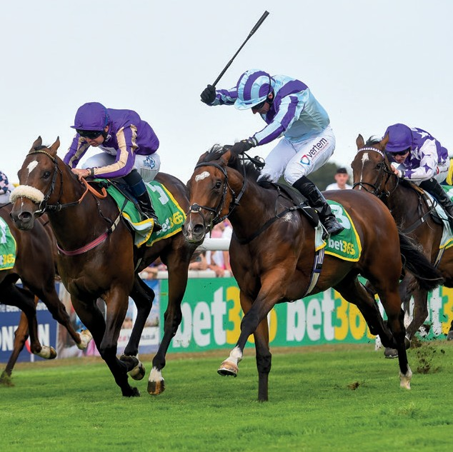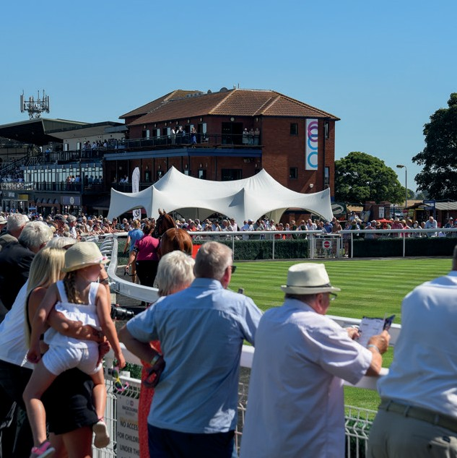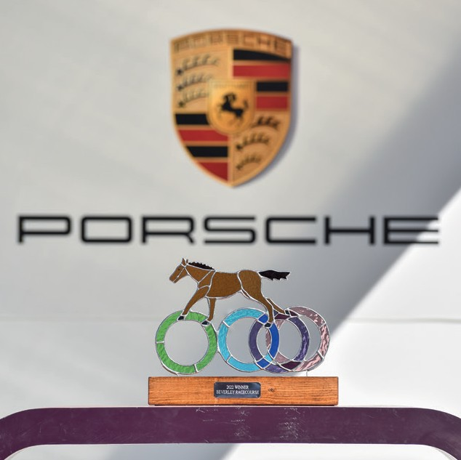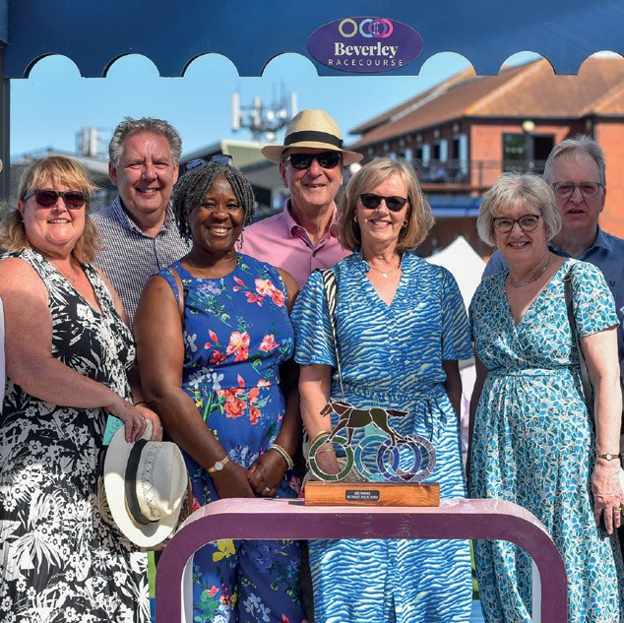

**Time Well Spent**

**Welcome to Beverley Racecourse**

Beverley Racecourse has been at the heart of the local community and

Yorkshire since 1690. We’re an influential and iconic venue, the only one of its kind in East Yorkshire and oﬀer superb opportunities to reach an engaged and diverse local audience via a unique and exciting medium.

The racecourse oﬀers a platform for businesses, individuals or groups to

showcase their brand, celebrate an anniversary or to generate awareness to

circa 120,000 visitors a year.

Whether it's a season long partnership, advertising & branding opportunities, raceday sponsorship or brand activations. We have a portfolio of partnership packages and take a tailored, personable approach to help you achieve any

specific objectives.

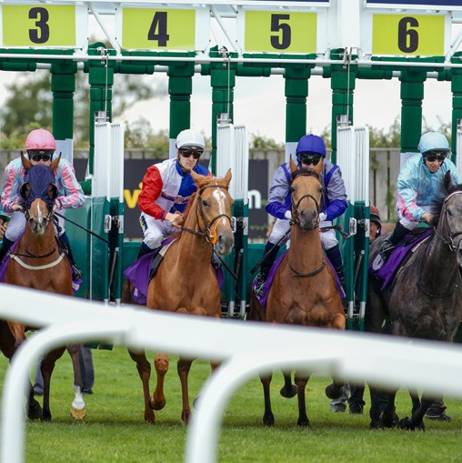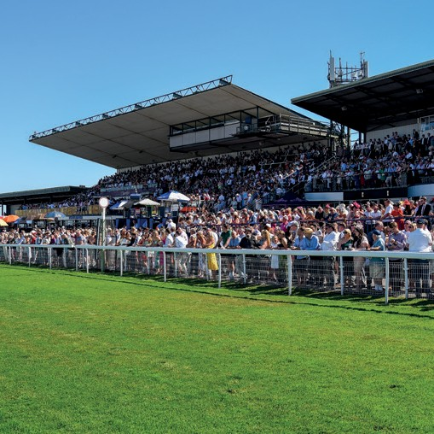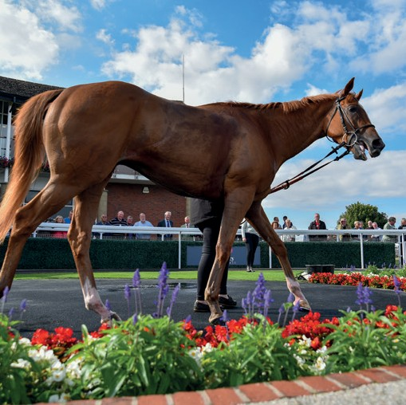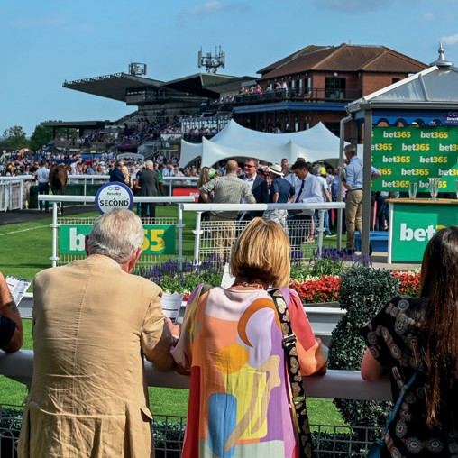

*“Coming together is a beginning; keeping together is progress; working together is success”*

**Henry Ford**

# Partnerships with Beverley Racecourse

With 19 racedays from April to September, featuring Saturday racedays, bank holidays, midweek evenings and a fternoons there's something to suit

everyone’s needs.

The team at Beverley Racecourse work closely with our partners across the

season and on each raceday.

We are always looking at new and innovative routes to market , plus at the

same time growing our existing customer marketplace. From start to finish the team at Beverley will work closely with you in delivering and exceeding your

goals from a partnership.

##### 20K



**3K**

#### 50K

##### 32K

#### 1 MILLION



#### 120K+

#### 50K+

S O C I A L M E D I A F O L L O W E R S

A N D G R O W I N G

S O C I A L M E D I A I M P R E S S I O N S

A V G P E R M O N T H ( A P R - S E P T )

C U S T O M E R

L I V E A U D I E N C E

R A C E C A R D S A L E S , R U N N E R S & R I D E R S A N D D O W N L O A D S



**Racing media partner**

#### 20K

P E O P L E O P T E D I N

C R M M A R K E T A B L E D A T A B A S E

#### 120K

L A R G E S C R E E N

& H O S P I T A L I T Y C C T V V I E W S

#### 60K

S U B S C R I B E R S T O

C I R C A 2 0 M H O M E S I N T H E U K A N D I R E L A N D



**Our Partners**

Porsche Centre Hull

# Season Packages



## Y E A R R O U N D P A R T N E R S H I P A N D E X P O S U R E

### **P L A T I N U M E N C L O S U R E P A C K A G E**



**P O A ( O N L Y 3 A V A I L A B L E )**

**P E R F E C T F O R**

**Large businesses looking for a highly visible and positive partner brand in the region, including a set of extensive physical, digital and ticketed assets.**

* Naming rights to an enclosure; e.g. the Powergen Premier Enclosure
* 20 premium branding sites within the enclosure (production and install costs are not

included)

* Company logo on enclosure ticket
* Exhibition space and opportunity to bring a street team to five meetings
* Full page advert in every racecard
* Big screen airtime
* Home page listing on Beverley Racecourse website
* Press launch event at the racecourse
* Social media campaign to be cra fted around your specific goals
* 10 Premier Enclosure tickets to each race meeting (transferrable)

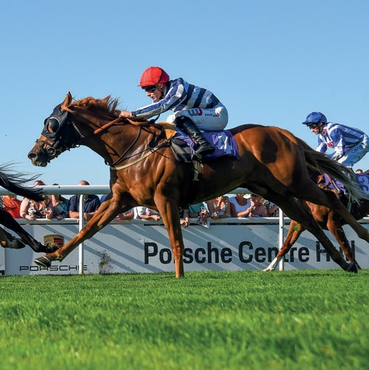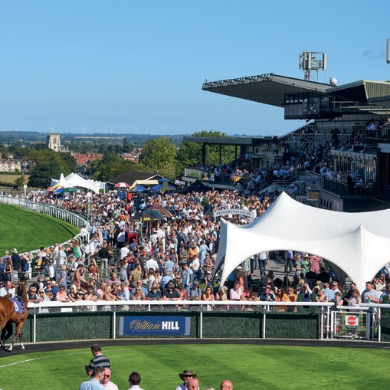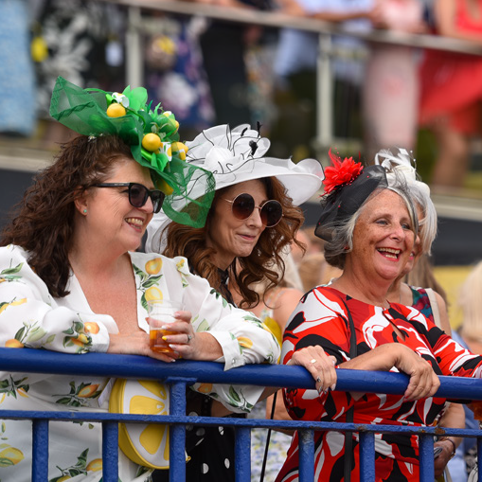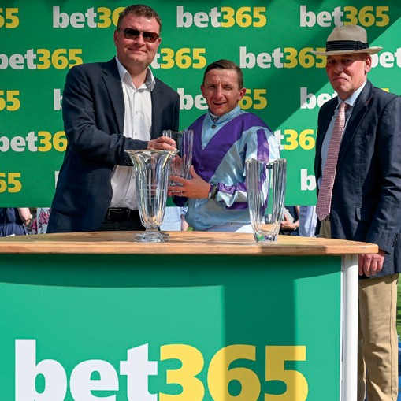

### **G O L D S E A S O N P A C K A G E**



**£ 3 4 0 0** + V A T

**P E R F E C T F O R**

**Businesses looking to reach racegoers throughout the season, both on course and digitally, as well as oﬀering tickets that could be used for directors, employees or customers.**

* Advertising board on the final furlong (Cost of Production and install not included)
* Two tickets to every race meeting (transferrable)
* Website news story
* Six social media links, including one giveaway if suitable.
* Half page advert in the racecard at every meeting
* Advert on the big screen at every meeting
* 10 bathroom door sites
* Website link for one year

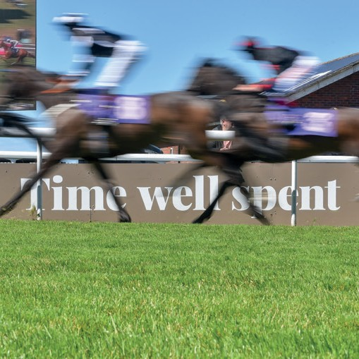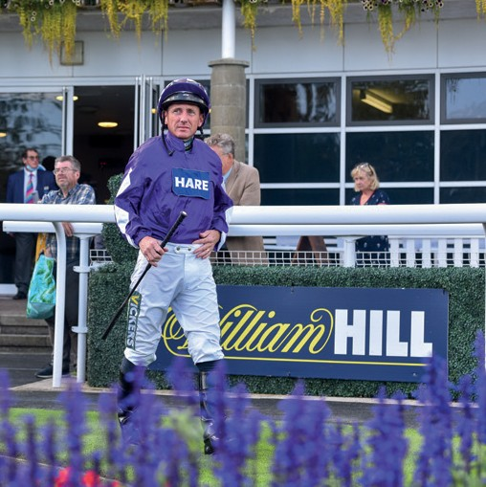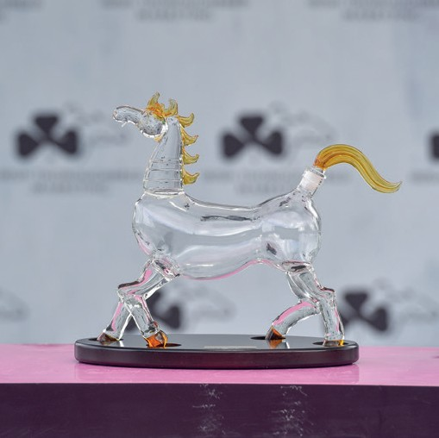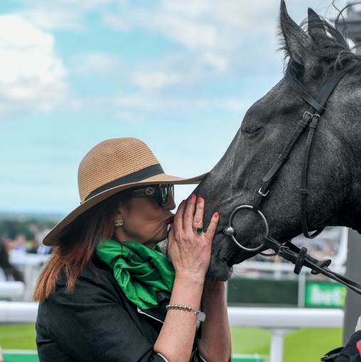

### **S I L V E R S E A S O N P A C K A G E**



**£ 5 5 0** + V A T

**P E R F E C T F O R**

**Small to medium sized local businesses looking to reach racegoers throughout the season, whilst obtaining exceptional value**

* Advert on the big screen at every meeting
* 10 bathroom door sites
* Website link for one year
* One social media giveaway. (This is dependent on you having something to

giveaway; we find this to be the best way to engage our followers with your brand.)

* Two tickets to Ladies’ Day presented by Porsche Centre Hull or a Saturday race meeting of

your choice.

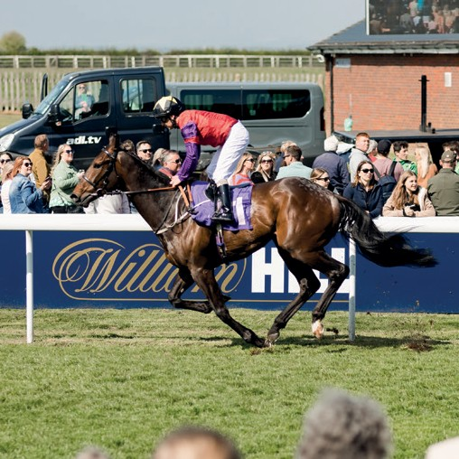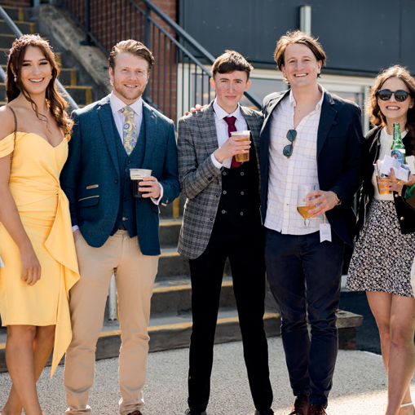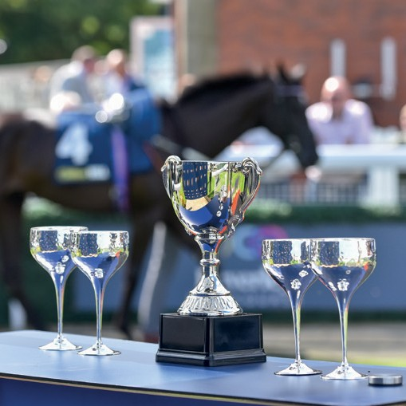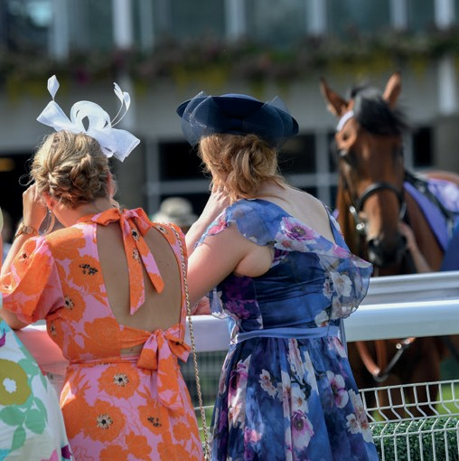

# Raceday Sponsors



## I M P A C T O N A R A C E D A Y

### **R A C E D A Y S P O N S O R S H I P**



F R O M £ 4 , 0 0 0 + V A T

**P E R F E C T F O R**

**The quality mark for sponsorships, this raceday is completely dedicated to your brand**

**or business, oﬀering excellent brand visibility both digitally and on site, as well as a**

**chance to really impress customers and clients with VIP treatment throughout the day.**

**Best paired with hospitality to enjoy the day in comfort.**

* Naming rights to the day (e.g. Ladies Day presented by Porsche Centre Hull)
* Naming rights to five races (e.g. The Tyresavings.com Handicap Stakes)
* Visit to the Parade Ring to choose the Best Turned Out Horse, followed by a champagne viewing of your races
* Presentation of trophy to the winning owners, including photo memento
* Exclusive behind-the-scenes tour of the course for you and guests
* The front cover of the racecard and a minimum of two individual full page adverts
* Big screen airtime for promotional video and adverts
* Exhibition space, including product placement and the opportunity to bring a street team
* Logo and name incorporation into all raceday branding and advertising
* Social media posts linking to your business before and a fter raceday
* Brand name and link in pre-event email to all attendees (GDPR compliant)

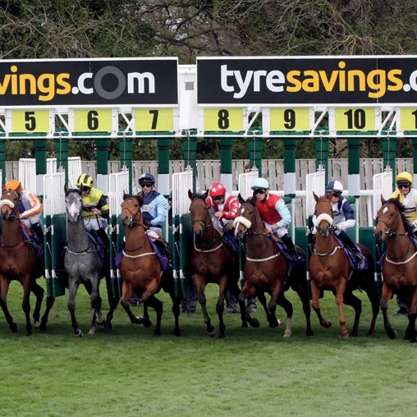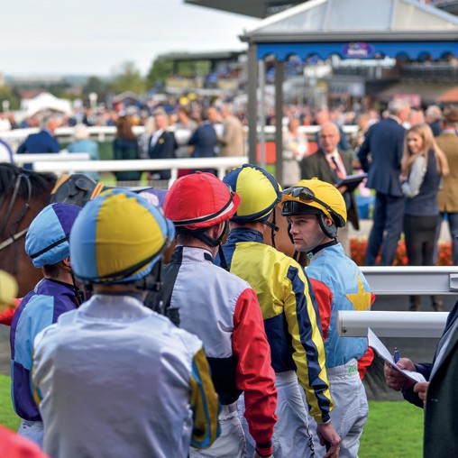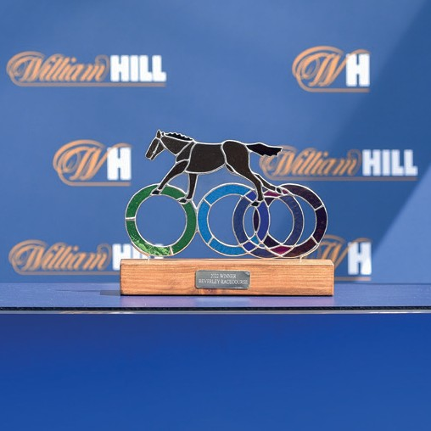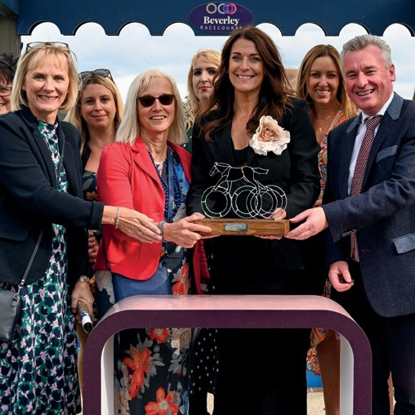

### **S I N G L E R A C E S P O N S O R S H I P**



£ 8 5 0 + V A T

**P E R F E C T F O R**

**Superb as a standalone day out, or in addition to a hospitality package to really**

**impress your guests, this also features some excellent on-the-day brand visibility.**

* + Single race sponsorship – (The Jacksons of Yorkshire Handicap Stakes)
  + Four Premier Enclosure tickets
  + Visit to the Parade Ring to choose the Best Turned Out Horse, followed by a champagne viewing of the race
  + Presentation of trophy to the winning owners, including photo

memento

* + A full page advert in the racecard & on the big screen
  + A choice of 4 premium banner sites

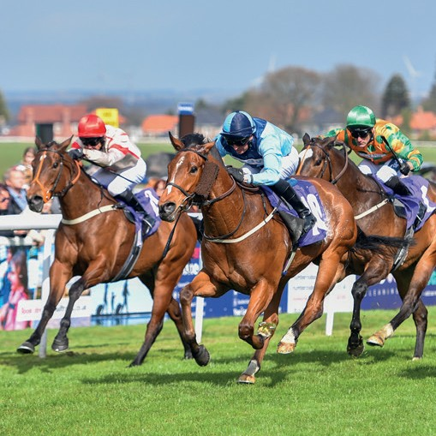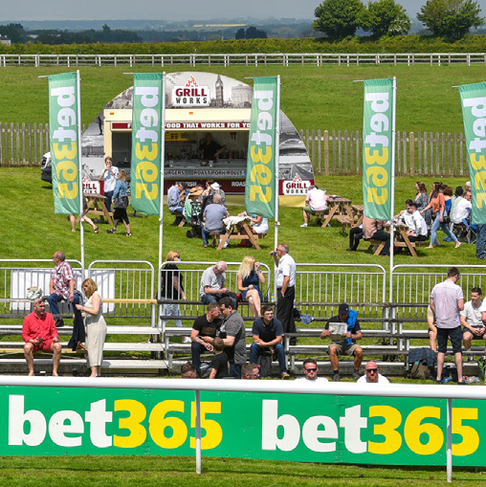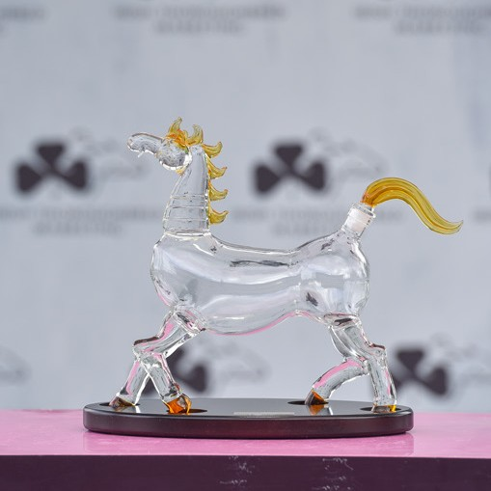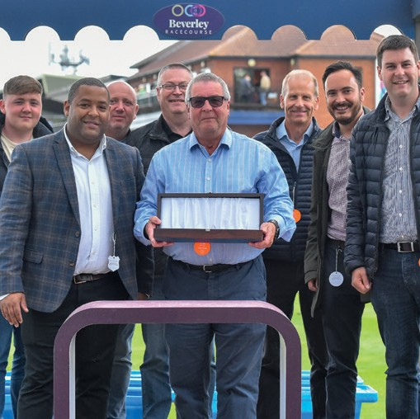

### **P R O D U C T P L A C E M E N T P A R T N E R**



£ 1 6 0 0 + V A T

**P E R F E C T F O R**

**Perfect when you have a product to launch to an engaged local audience.**

* + Exhibition space and the opportunity to bring your own street team
  + Brand name and link in pre-event email (GDPR compliant)
  + Full page racecard advert
  + Big screen airtime for promotional video and adverts
  + Brand activation (to be discussed as this is completely individual to each company)
  + Naming rights to one race on the day
  + Interview with raceday presenter following your race

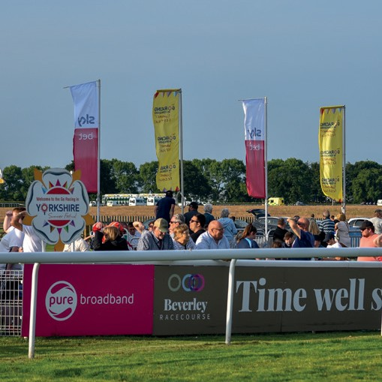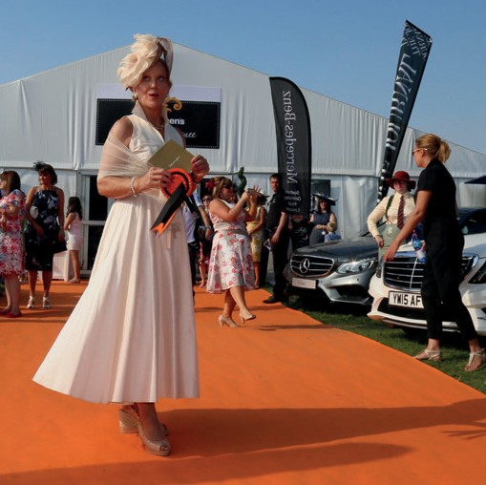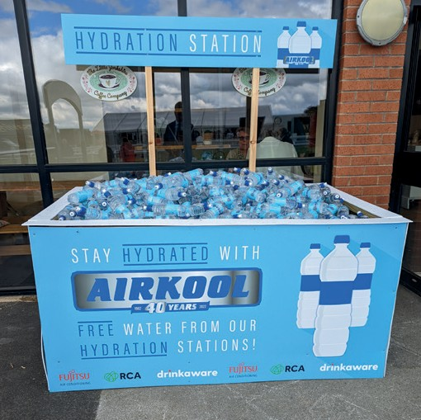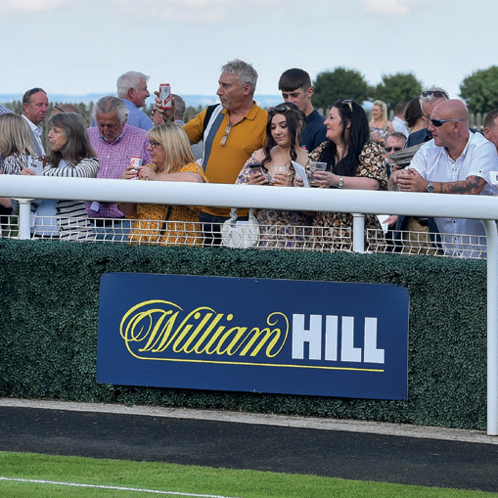

### **T E S T I M O N I A L S**



"Thank you so much for a great evening. The staﬀ were all fantastic and really looked a fter the whole party.

Everyone enjoyed it and some of the girls are planning their next visit already!"

*Kaye Garwood - Senior Sales Manager Beal Homes*

We had a great time at your racecourse yesterday and everyone really enjoyed the event.

In particular the staﬀ in the box worked so hard and went above and beyond our

expectations. They really were excellent and all our employees commented on it so please pass on our thanks to them for their eﬀorts

*Helen Starkey - HR & Comms Director - Mitsubishi Chemicals*

“We had an absolutely fabulous day and we are so grateful to you and the team for looking a fter us, it was really special for all the team and especially to be in the parade ring with

yourself and Adele was a wonderful experience. We are looking at bringing the whole team

next season.”

*Katie Matthews – Operations Coordinator RWE*

We have been working alongside Joe and the team at Beverley Racecourse as the headline

sponsor for the Ladies Day meet, they are all a pleasure to deal with and prompt to respond with any questions or queries. The team was organised, attentive and flexible with our

requirements, and we highly recommend working with them.

*Richard Kitteridge – Brand Director Porsche Centre Hull.*

**Contact Us**

**To discuss any of these packages, or to book, please contact**

**Joe Pollak on 01482 867488**

**or email** [**joe@beverley-racecourse.co.uk.**](mailto:joe@beverley-racecourse.co.uk)